Eco Club Vardhaman College, Bijnor
Information of Eco Activities from Session 2016-17 to Session 2019-20
Overview: Eco Club of Vardhaman College was constituted in the session 2016-17 under the supervision of Co-ordinator Dr. Anita Chaudhary, an Assistant Professor of Botany Department. The main aim of establishing of Eco Club was to conserve the natural resources and natural environment to create Eco friendly environment and create awareness of biodiversity conservation and local environmental issues among students and to create a clean, green consciousness among children through various innovative methods.
Eco Club plays an important role in certain environmental awareness amongst the future generation. The main motive of Eco Club is to nurture and teach the importance of environment to students.
Our Vision- To be best institute for protecting and creating environment awareness by educating the youth offering programmes and resources for the students.
Objectives-
- To motivate the students to keep their surroundings green & clean by undertaking plantation of trees.
- To promote culture of conservation of water by minimizing the use of water.
- To maintain cleanliness in our campus.
- To educate students to create awareness amongst public and sanitary workers, so as to stop the indiscriminate dumping and burning of waste which causes respiratory diseases.
- Special emphasis on the development of Botanical Garden because Botanical Gardens practice & provide training for conservation of nature. They also provide instructions for home gardening & care of plants in winter & summer. They provide aesthetically pleasing environment and thus play a major role in providing sound mental health.
Major Activities-
Session 2016-17-
- Co-ordinator- Dr. Anita Chaudhary.
- Eco Club committee was launched in this session.
- Project for Botanical Garden, project for solar panels & project for rain water harvesting system were submitted to the principal.
- The area allotted for Botanical Garden was made concrete free with the help of J.C.B. The soil of this area was ploughed & leveled with help of tractor. The fertility of soil was increased by organic & chemical fertilizer.
- Fresher students were motivated to be Eco friendly by delivering lectures during their orientation program of session 2016-17.
- Name Plates were tagged on important trees of Botanical Garden & College campus.
- “Peepal Tree” the main attraction of Botanical Garden was made free from Amar Bel (Cuscuta reflexa).
- Lopping of existing trees were made.
- Ornamental were planted in Botanical Garden.
- Attempts were made to cultivate tobacco free, polythene free campus.
- Compost pit was constructed to prepare compost from the waste of college campus i.e. dried tree leaves, papers & grass litter etc.
Session 2017-18
- Co-ordinator- Dr. Anita Chaudhary
- Regular meetings were held by Eco Club committee.
- Fresher students were motivated to be Eco friendly during their orientation program of session 2017-18.
- Our Principal/Management provided some solar light as suggested by Eco Club last year.
- Project of Botanical Garden got momentum in the session 2017-18 under the able guidance of our Principal Dr. C.M. Jain.
- Some exotic species were planted in the Botanical Garden.
- Compost prepared in the compost pit was used for the lawn of Botanical Garden.
- Some articles related to gardening were also purchased.
- A gardener was also appointed to look after the Botanical Garden.
- For the conservation of bird species Eco Club Committee had recommended for some bird cages. Our Principal help the Eco Club in arranging bird cages on the trees. Water pots & feed for birds had also been arranged.
Session 2018-19-
- Co-ordinator- Dr. Ajay Chaturvedi, Head Department of History.
- Two days (Dated 29 Nov -30 Nov 2018) Eco activities like plantation, poster competition, Essay writing competition etc were arranged.
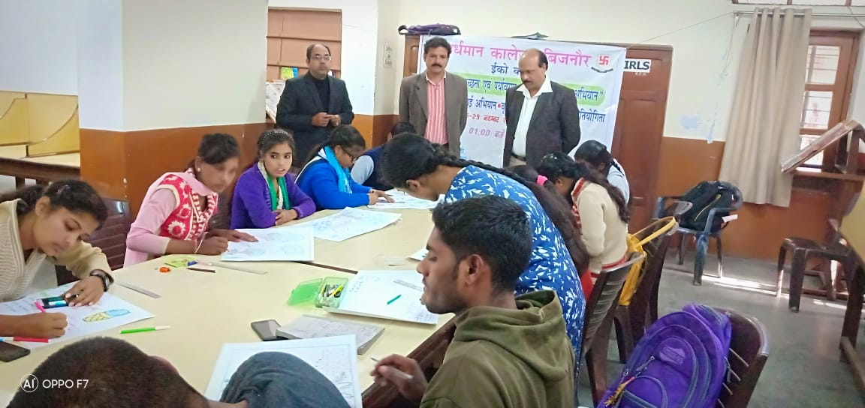

Chart Competition in the session 2018-19
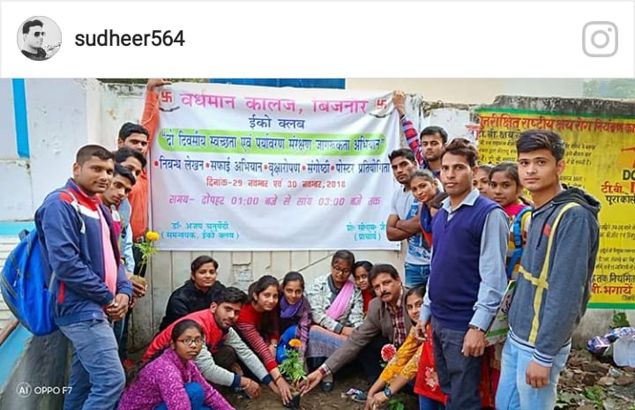

Plantation in the session 2018-19
Session 2019-20
1. Co-ordinator- Dr. Anita Chaudhary
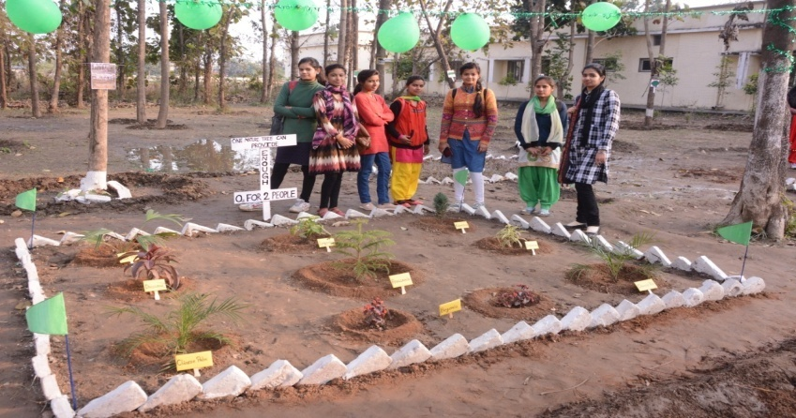
2. “Micro Project” activity was arranged in the Botanical Garden on 8 Feb 2019 for the development of Botanical Garden. The area of the garden is divided into eight parts. The students of B.Sc 3rd year Botany were also divided into 8 groups. Each group had 8-10 students. The task for each group was to clean and develop the garden area provided to the group. The prize & certificate were distributed to the members of those groups which stood I, II, & III by our honorable Principal Dr. C.M. Jain. Judgment was made by the faculty members of Botany Department.

“Micro Project” activity in session 2019-20
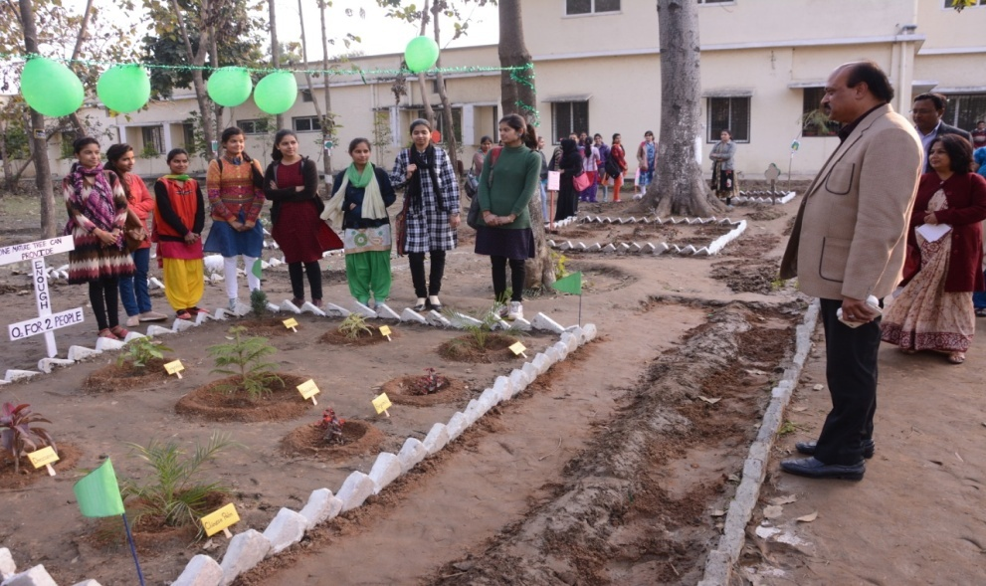

“Micro Project” activity in session 2019-20
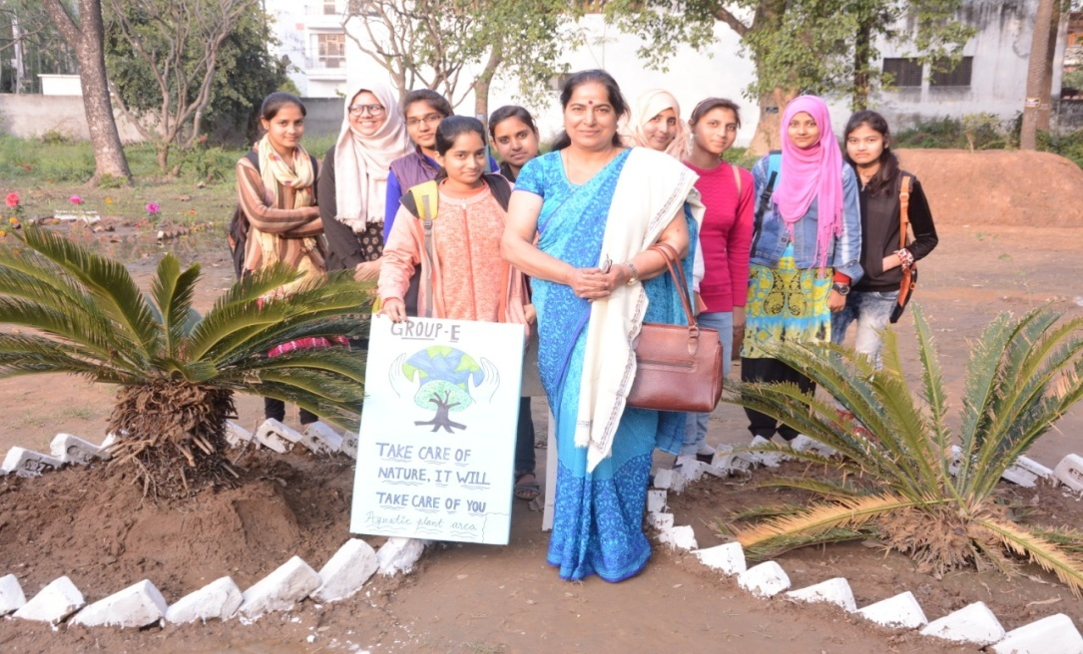

“Micro Project” activity in session 2019-20
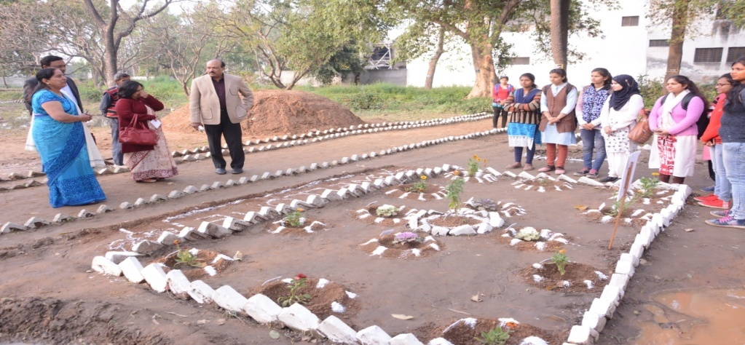

“MicroProject” activity in session 2019-20
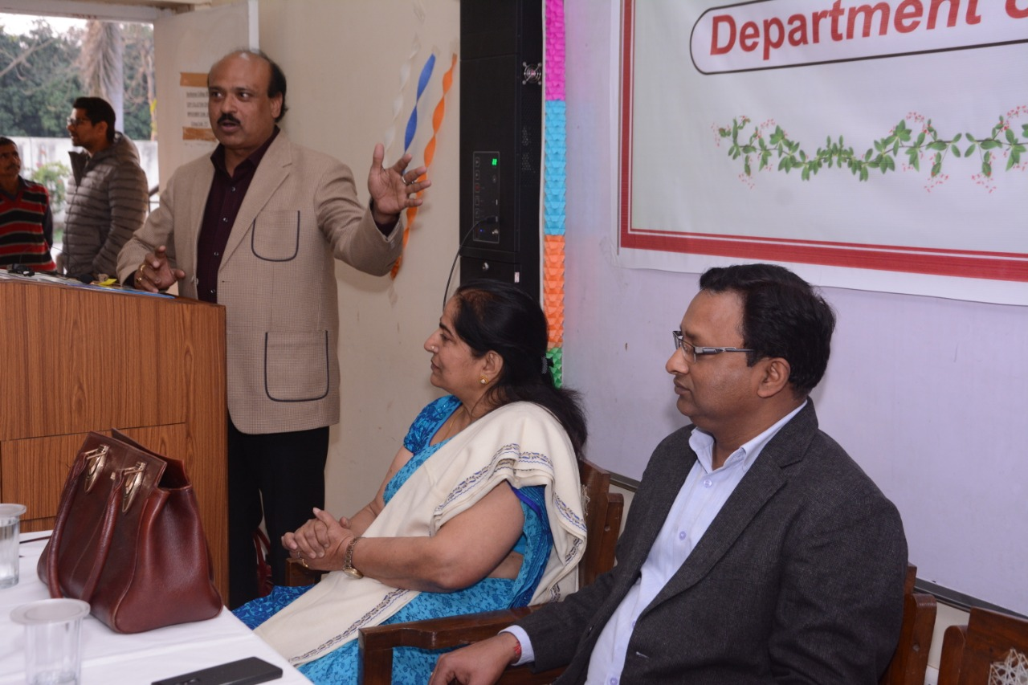

“Micro Project” activity in session 2019-20
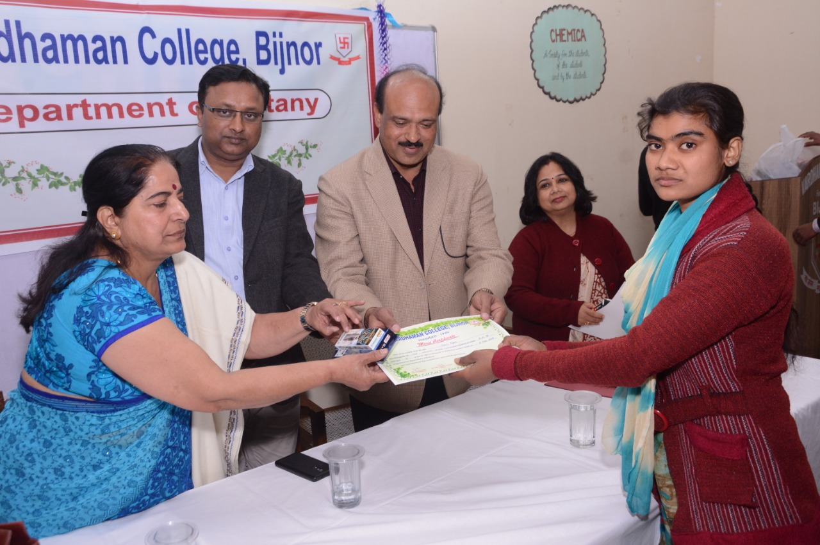

“Micro Project” activity in session 2019-20

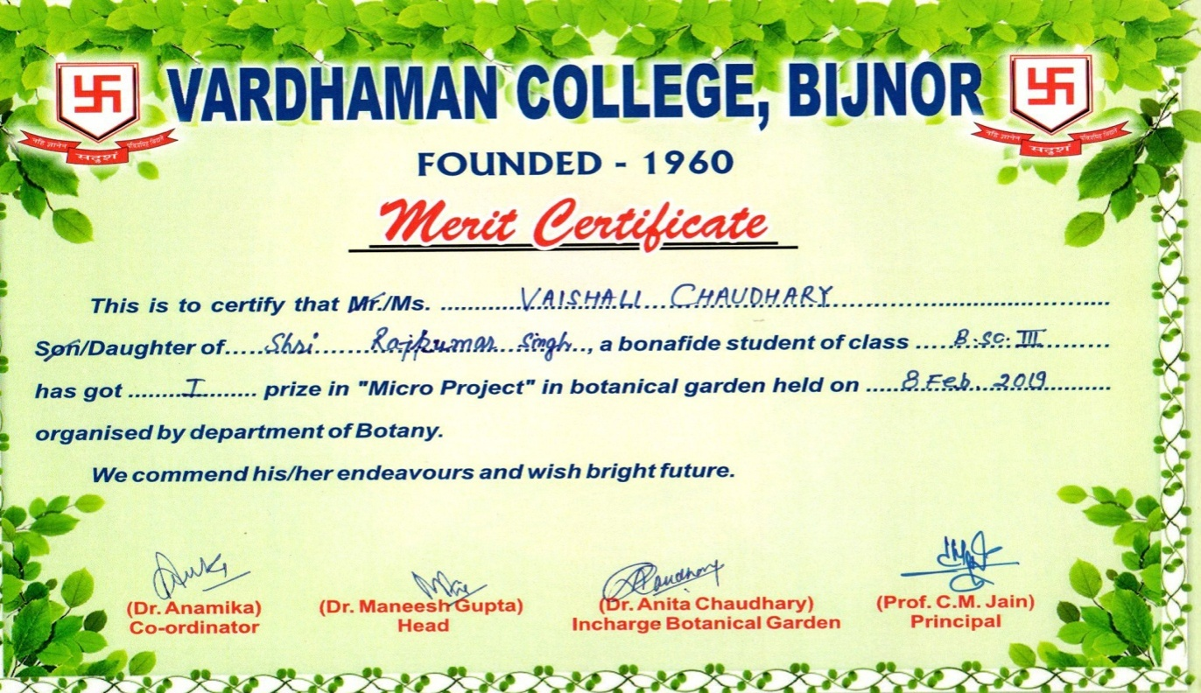

Certificate distributed to the winner group in the “Micro Project” activity in the session 2019-20
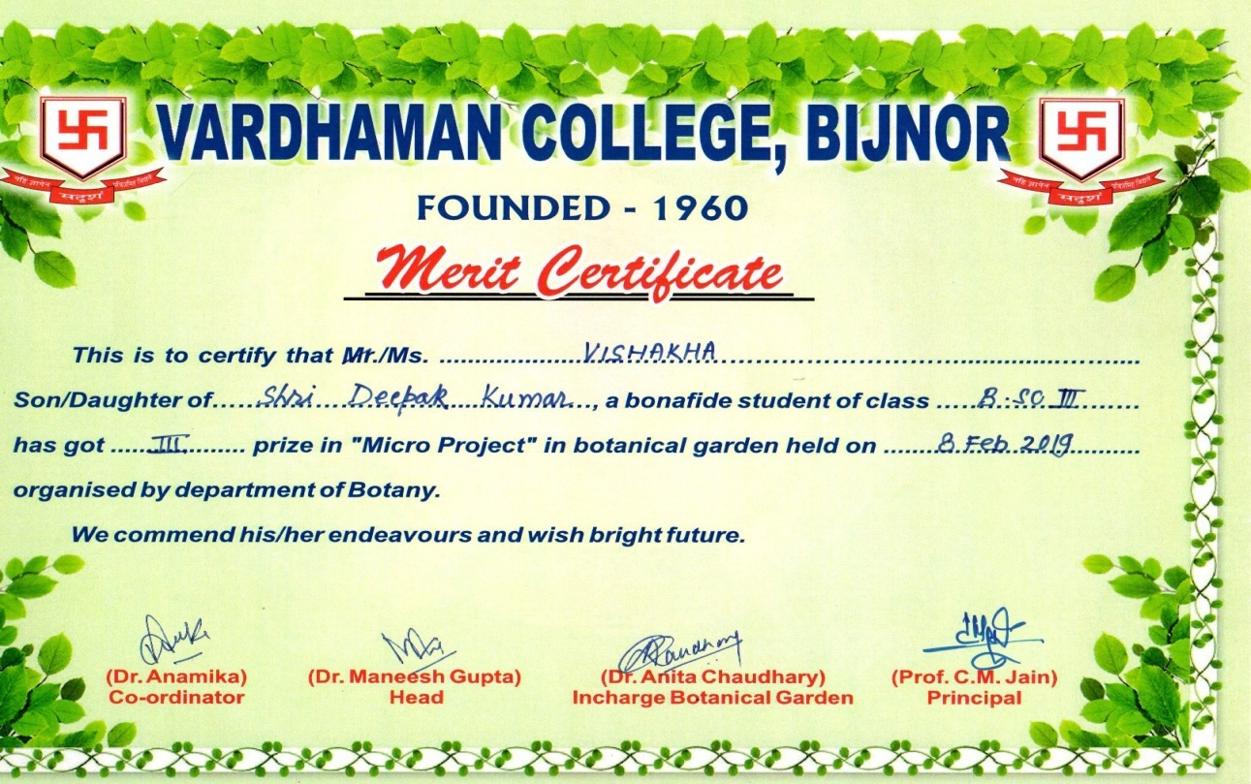

Certificate distributed to the winner group in the “Micro Project” activity in the session 2019-20
2. “Paryavaran Mahotsava” was celebrated from 15 July to 20 July 2019
- On 15 July plantation of “Champa” was made along the boundary of Vardhaman College
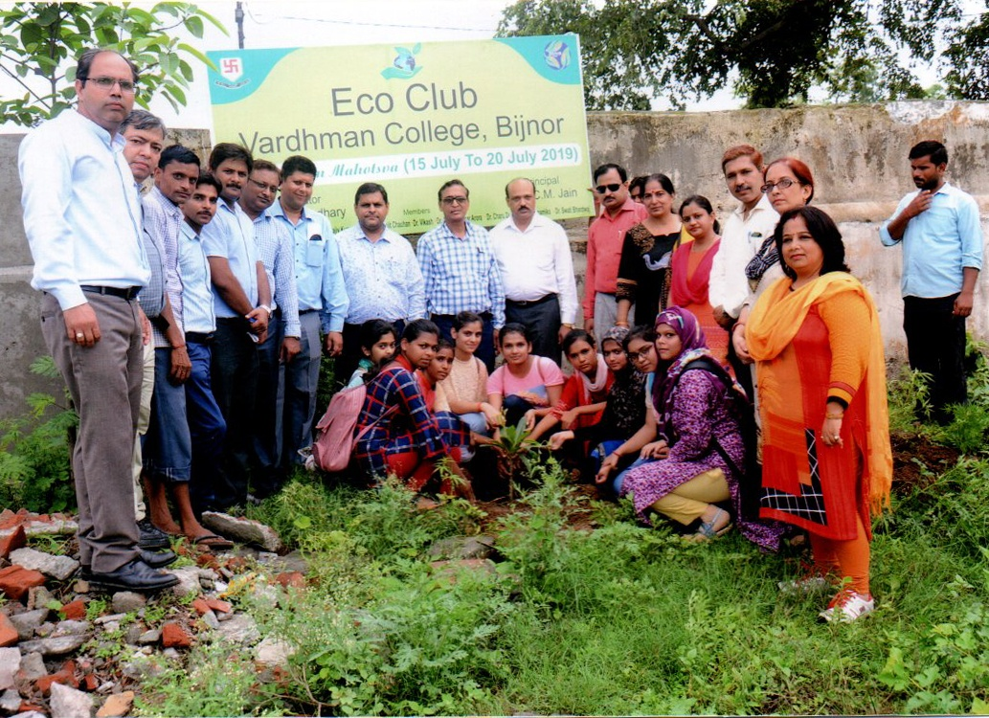

“Champa” Plantation in the session 2019-20
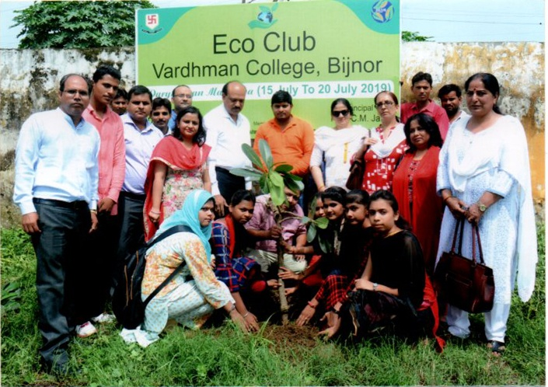

“Champa” Plantation in the session 2019-20
ii. On 16th July 2019 a competition was arrange in the Botany Theatre on “Planters from waste material”. Dr. Rajeev Johri, Chairman of Science faculty of Vardhaman College and Dr. Vandana Jain, Head Department of Sanskrit were appointed as Judges. Many entries of planters were received. Ms. Vaishali Goel, Ms. Sonali Goel & Vishakha got I, II & III prize respectively.
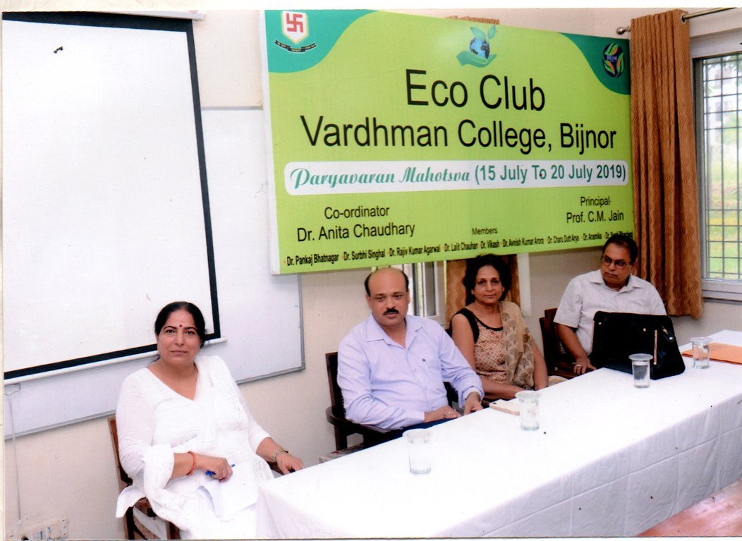

“Planters from waste material” competition in the session to 2019-20
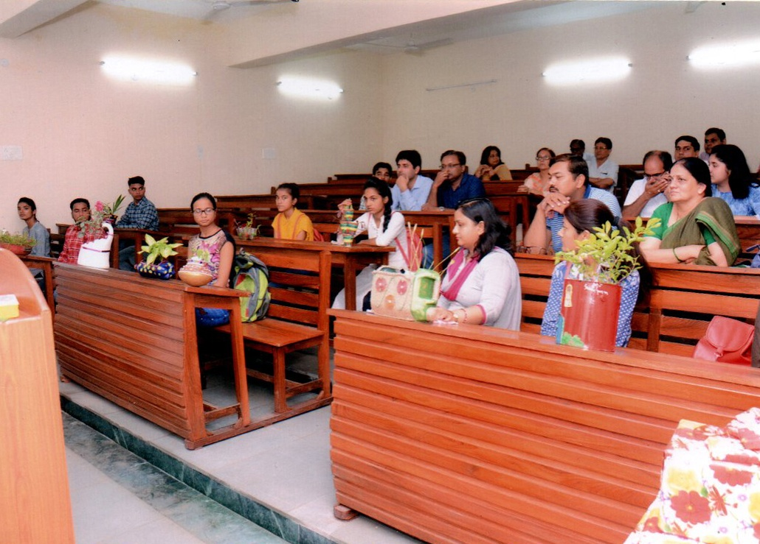

“Planters from waste material” competition in the session to 2019-20

“Planters from waste material” competition in the session to 2019-20

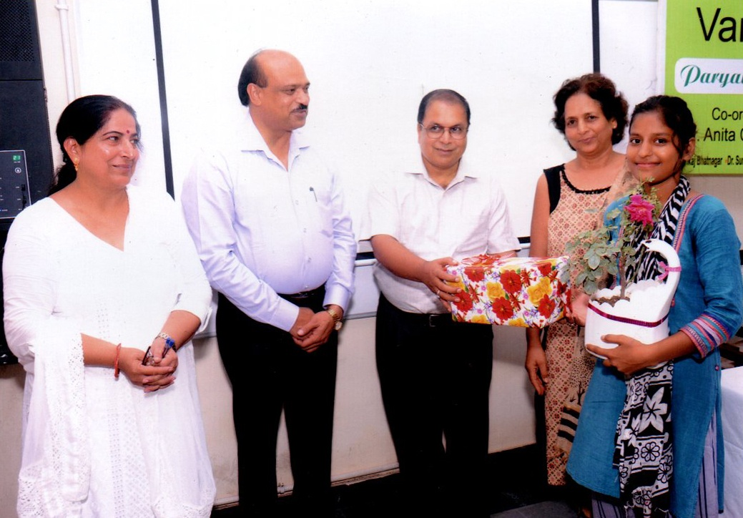

“Planters from waste material” competition in the session to 2019-20
iii. On 18 July 2019 pamphlets with title ”LokLF; j{kd ikS/ks yxk;as] fujksxh jgas&i;kZoj.k cpk;sa” were distributed in the buses, at railway station, Road ways bus stand, Shakti chauk and inside the city. In These pamphlets the importance of some medicinal plants were given. So that people would aware of them and would grow them in their home to get a healthy life.
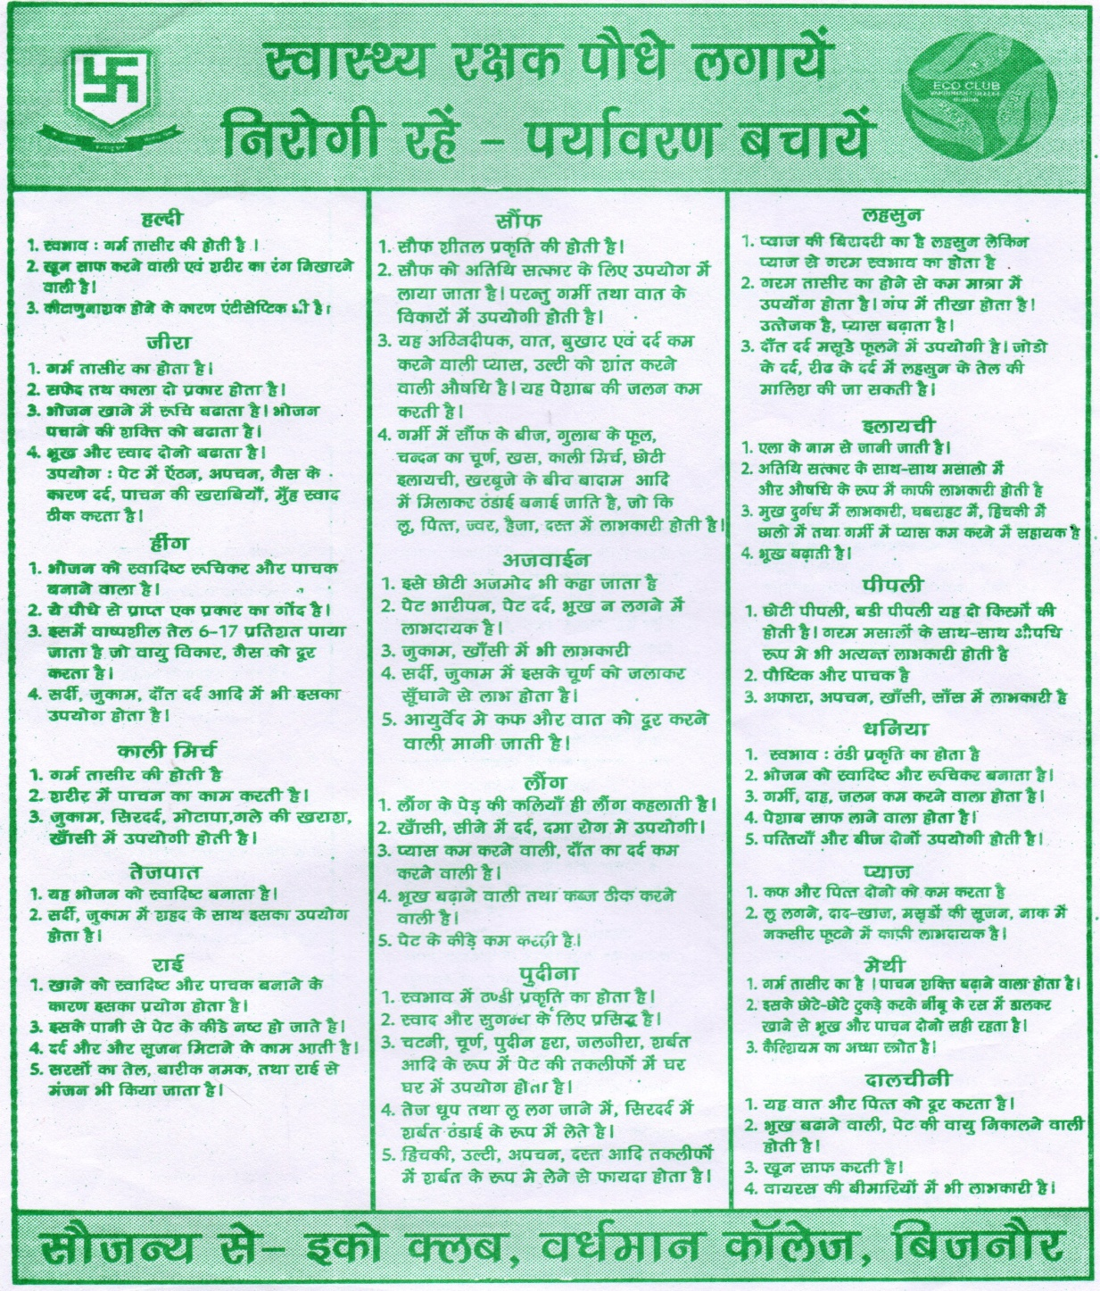

The distributed pamphlet
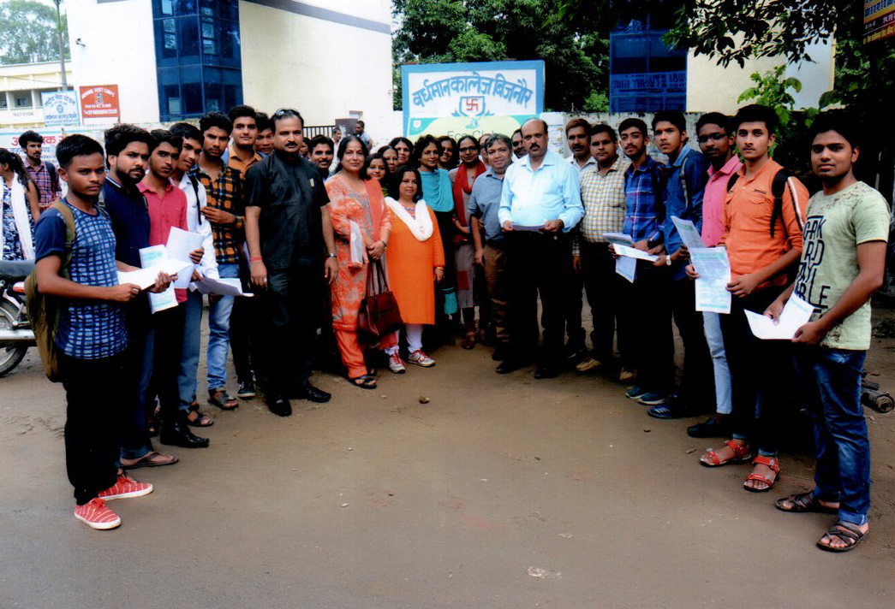

Distribution of pamphlets in the session 2019-20

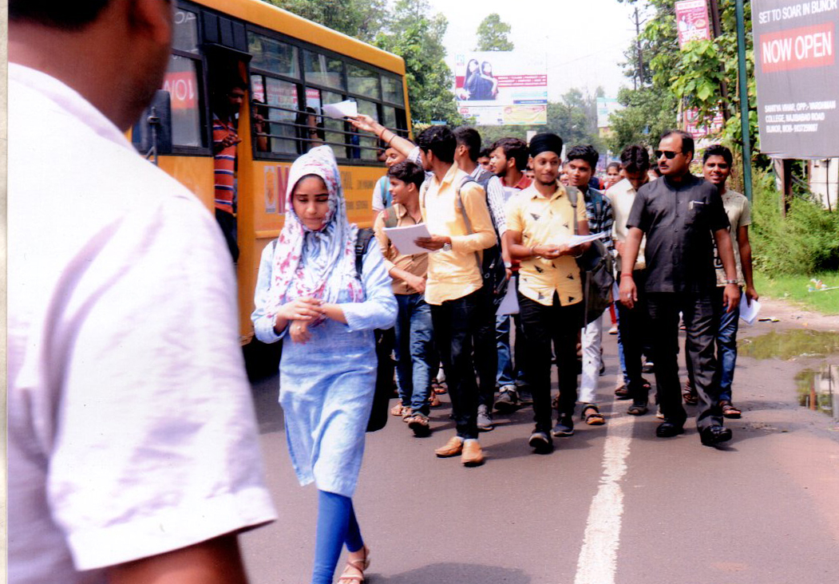

Distribution of pamphlets in the session 2019-20
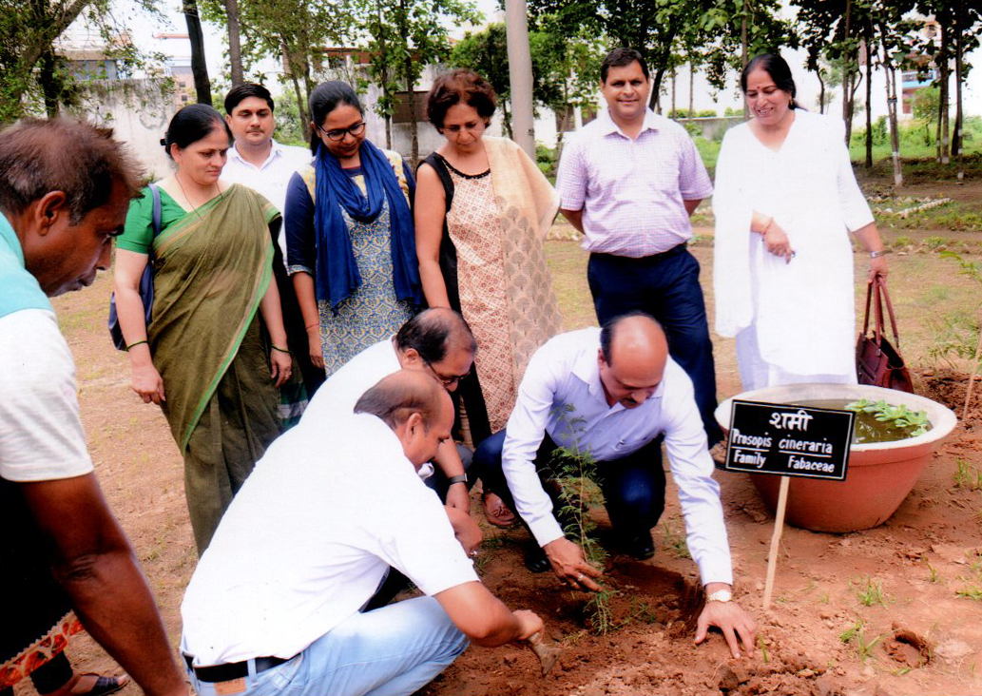
iv. On 19th July 2019, twenty medicinal plants were added in the Botanical Garden.

Plantation of medicinal plants in the Botanical Garden

V. On 20 July plantation of hundred plants was also made in the college campus to celebrate Pryavaran Mahotsava.
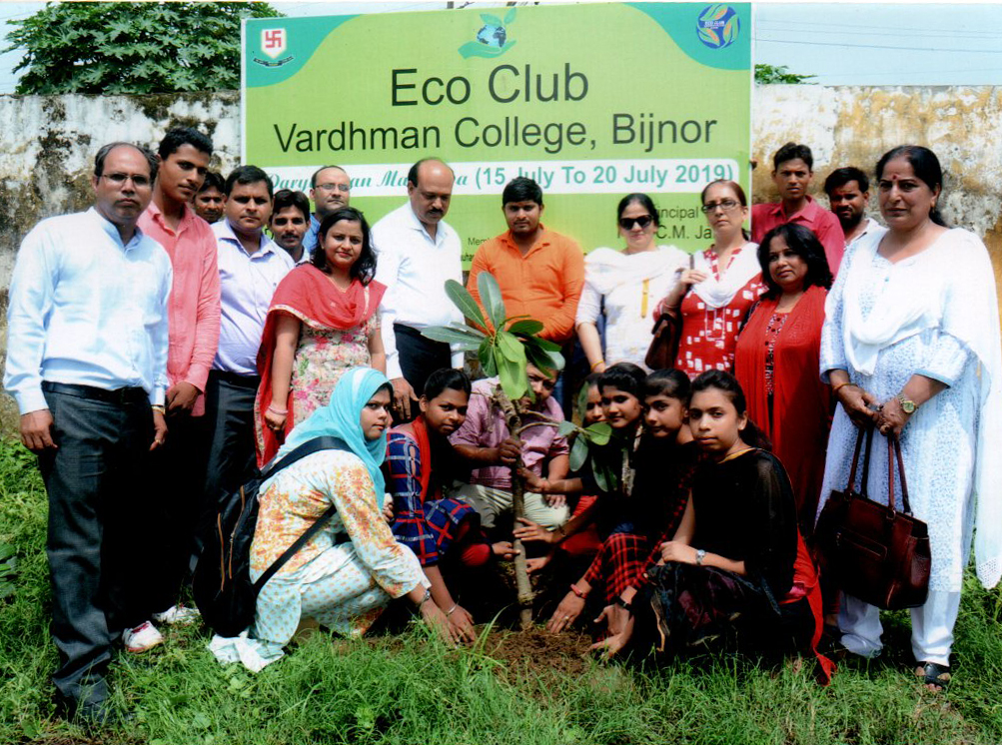

Another plantation on 20th July 2019 to celebrate Pryavaran Mahotsav.
3. On 5th July 2020 Eco Club of Vardhaman College made a joint project with Navchetna group. In this project 150 plants were planted in the College campus. Hand sanitizer and masks were also distributed to the students and faculty members by our honorable Principal Dr. C.M. Jain.
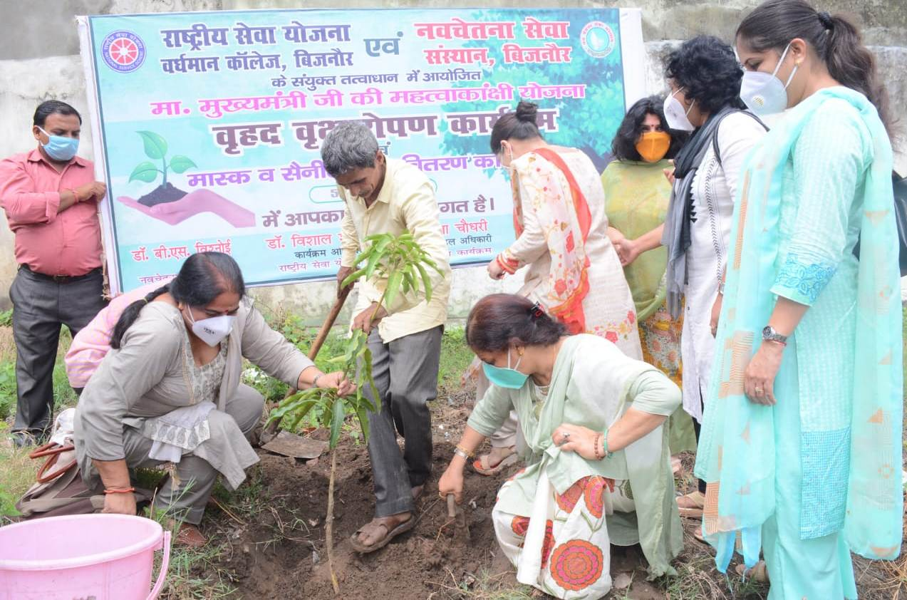

Plantation on 5th July 2020 with Navchetna group

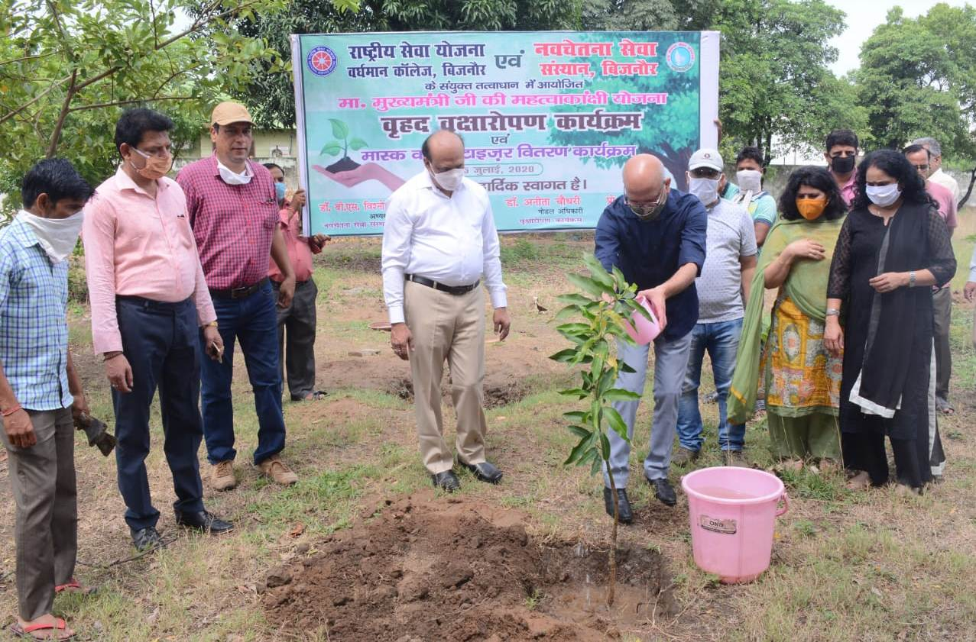

Plantation on 5th July 2020 with Navchetna group

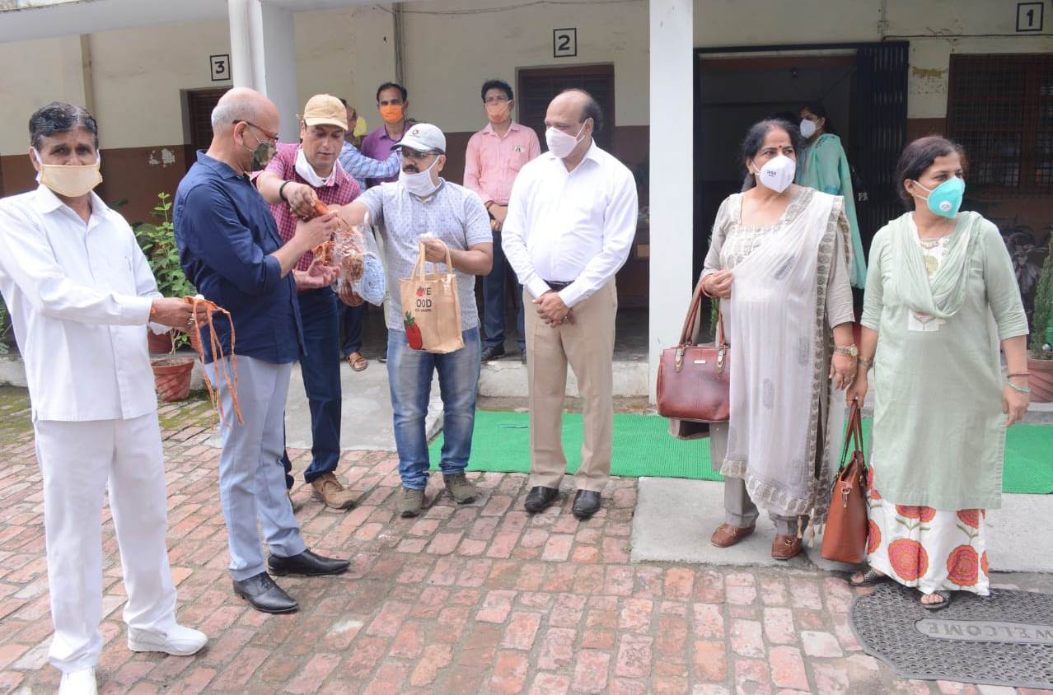

Distribution of sanitizer and masks on 5th July 2020

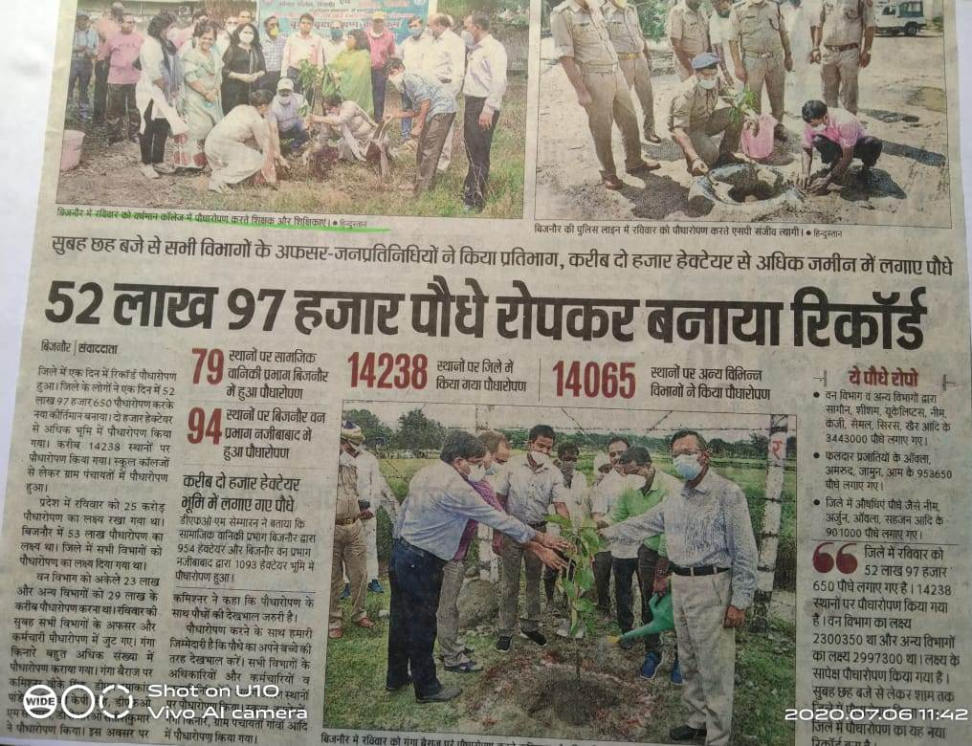

News paper cutting which cover the joint project held on 5th July 2020 in the Session 2019-20.
The Eco Club committee for the session 2020-21
01- Dr. Mukesh Kumar - Prof. In charge
02- Dr. Anita Chaudhary - Co-ordinator
03- Dr. Pankaj Bhatnagar - Member
04- Dr. Surbhi Singhal - Member
05- Dr. Rajiv Kumar Agarwal - Member
06- Dr. Lalit Chauhan - Member
07- Mr. Vikash - Member
08- Dr. Avnish Kumar Arora - Member
09- Dr. Charu Dutt Arya - Member
10- Dr. Anamika - Member
11- Dr. Swati Bhardwaj - Member

This report is submitted to Prof. C.M. Jain, Principal of Vardhaman College by Dr. Anita Chaudhary Co-ordinator of Eco Club.

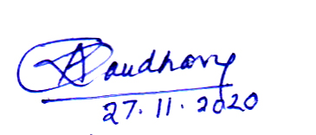

Dr. Anita Chaudhary
Co-ordinator Eco Club
Vardhaman College, Bijnor.

